2026 MEMBERSHIP PHORM
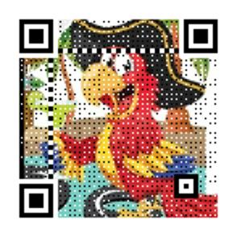

Name:____________________________________ Birthday(month/day only)__________________
Address:___________________________________________________________________________
City:_______________________________ ST:_______ Zip:_____________
Phone:_____________________________ Email:______________________________________

----------------------------------------------------------------------------------------------------------------------------------------------------

Name:___________________________________ Birthday(month/day only)____________________
Address:___________________________________________________________________________
City:_______________________________ ST:_______ Zip:_____________
Phone:_____________________________ Email:__________________________________
Memberships dues are renewed annually in JANUARY

We PARTY with a PURPOSE!
Mail Checks or Money orders payable to:
Canyon Lake Parrot Heads
119 Valley View Road
Wimberley, Texas 78676

Each member of the Canyon Lake Parrot Head Club is responsible for their own actions and behaviors and shall treat fellow members, guest hosts, personal property and the community with professionalism and respect. Members also agree to abide by local, state, and federal laws. Members also agree to abide by all by all Bylaws posted on club’s website.

